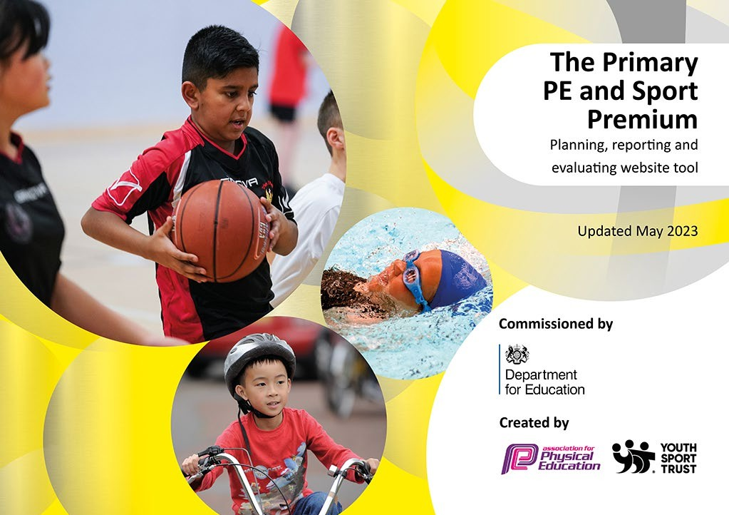

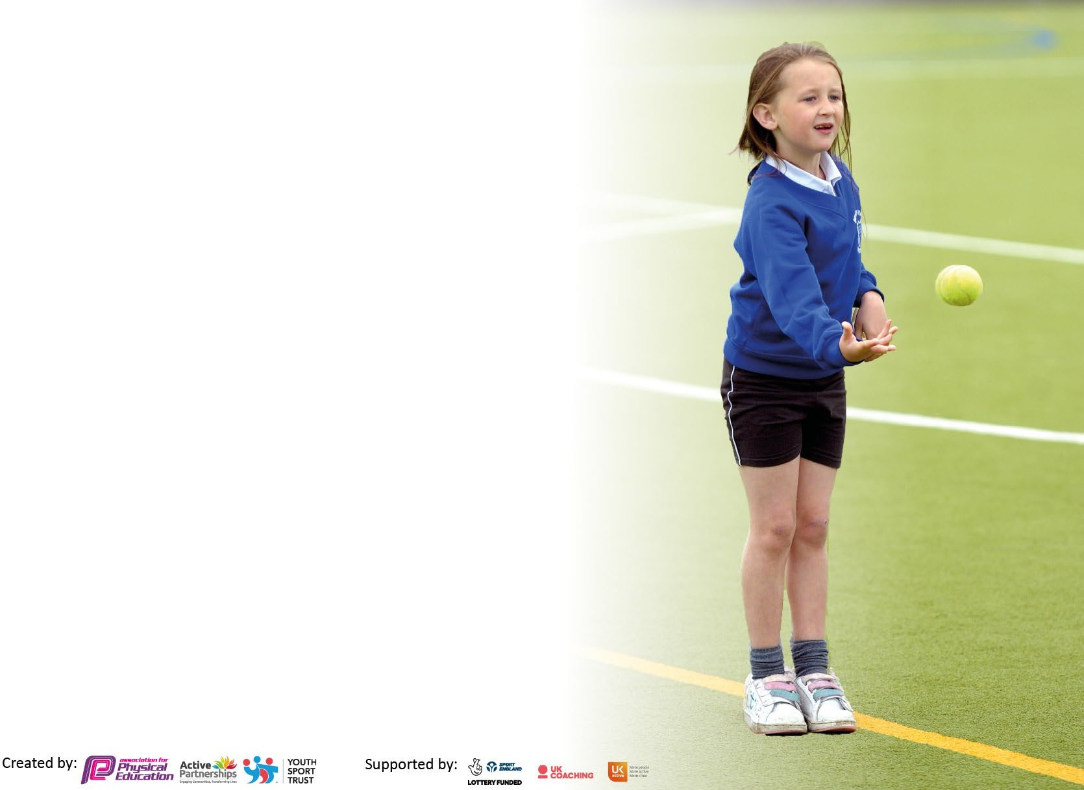
It is important that your grant is used effectively and based on school need. The Education Inspection Framework makes clear there will be a focus on ‘whether leaders and those responsible for governors all understand their respective roles and perform these in a way that enhances the effectiveness of the school’.
Under the Quality of Education Ofsted inspectors consider:
Intent - Curriculum design, coverage and appropriateness
Implementation - Curriculum delivery, Teaching (pedagogy) and Assessment
Impact - Attainment and progress
To assist schools with common transferable language this template has been developed to utilise the same three headings which should make your plans easily transferable between working documents.
Schools must use the funding to make additional and sustainable improvements to the quality of Physical Education, School Sport and Physical Activity (PESSPA) they offer. This means that you should use the Primary PE and sport premium to:
- Develop or add to the PESSPA activities that your school already offer
- Build capacity and capability within the school to ensure that improvements made now will benefit pupils joining the school in future years
- The Primary PE and sport premium should not be used to fund capital spend projects; the school’s budget should fund these.
Please visit gov.uk for the revised DfE guidance including the5keyindicatorsacrosswhichschoolsshoulddemonstrate an improvement. This document will helpyoutoreviewyourprovisionandtoreportyourspend.DfEencouragesschools to use this template as an effective way of meeting the reporting requirements of the Primary PE and Sport Premium.
We recommend you start by reflecting on the impact of current provision and reviewing the previous spend.
Schools are required to publish details of how they spend this funding, including any under-spend from 2021/2022, as well as on the impact it has on pupils’ PE and sport participation and attainment. The funding should be spent by 31st July but the DfE has stated that there will be no clawback of any unspent money so this can be carried forward into 2023/24.
We recommend regularly updating the table and publishing it on your website throughout the year. This evidences your ongoing self-evaluation of how you are using the funding to secure maximum, sustainable impact. Final copy must be posted on your website by the end of the academic year and no later than the 31st July 2023. To see an example of how to complete the table please click HERE.

Details with regard to funding
Please complete the table below.

Total amount carried over from 2021/22 | £
Total amount allocated for 2021/22 | £
How much (if any) do you intend to carry over from this total fund into 2022/23? | £
Total amount allocated for 2022/23 | £ 22,950
Total amount of funding for 2022/23. Ideally should be spent and reported on by 31st July 2023. | £ 22,950
Swimming Data
Please report on your Swimming Data below.

Meeting national curriculum requirements for swimming and water safety.
N.B. Complete this section to your best ability. For example you might have practised safe self-rescue techniques on dry land which you can then transfer to the pool when school swimming restarts.
Due to exceptional circumstances priority should be given to ensuring that pupils can perform safe self rescue even if they do not fully meet the first two requirements of the NC programme of study
What percentage of your current Year 6 cohort swim competently, confidently and proficiently over a distance of at least 25 metres?  N.B. Even though your pupils may swim in another year please report on their attainment on leaving primary school at the end of the summer term 2023.  Please see note above | 32%
What percentage of your current Year 6 cohort use a range of strokes effectively [for example, front crawl, backstroke and breaststroke]?  Please see note above | 36%
What percentage of your current Year 6 cohort perform safe self-rescue in different water-based situations? | 16%
Schools can choose to use the Primary PE and sport premium to provide additional provision for swimming but this must be for activity over and above the national curriculum requirements. Have you used it in this way? | No

Action Plan and Budget Tracking
Capture your intended annual spend against the 5 key indicators. Clarify the success criteria and evidence of impact that you intend to measure to evaluate for pupils today and for the future.

Academic Year: 2022/23 | Total fund allocated: 22, 950 | Date Updated: July 2023
Key indicator 1: The engagement of all pupils in regular physical activity – Chief Medical Officers guidelines recommend that primary school pupils undertake at least 30 minutes of physical activity a day in school |  |  |  | Percentage of total allocation:
 |  |  |  | 28%
Intent | Implementation |  | Impact
Your school focus should be clear | Make sure your actions to achieve | Funding | Evidence of impact: what do | Sustainability and suggested
what you want the pupils to know | are linked to your intentions: | allocated: | pupils now know and what | next steps:
and be able to do and about |  |  | can they now do? What has
what they need to learn and to consolidate through practice: |  |  | changed?:
To engage all pupils in regular short bursts of physical activity.  all children have opportunities to take part in physical activity daily. | 5 a day Subscription. Each class to use 5 a day as regular breaks throughout the day  Playtimes are resourced with high quality equipment to ensure that children are engaged and active at playtimes. | £334  £5000 | Pupils understand how having an active lifestyle and doing regular bursts of activity is good for physical and mental health.  Children enjoy more active playtimes (barrels, basketballs, parachute, skipping, French elastic). Skills are practised in team games with coaches, use of equipment e.g. basketball hoops. Team work and socialisation is encouraged with physical equipment. Core continues to be strengthened as the children develop and grow through the | Continue with this next year  This has been very successful. Further investment and development of the Play Leaders is needed next year.

Disadvantaged children have access to extra-curricular sports clubs. | All PPG children offered opportunities to attend external and internal sports clubs through funded places | £1050 | school. Children enjoy learning in the outdoor environment.  Children understand the importance of physical health and its links to wellbeing.  Encourages more children to be active in different ways  Places have been offered to PPG children. | This has been successful, continue next year
Key indicator 2: The profile of PESSPA being raised across the school as a tool for whole school improvement |  |  |  | Percentage of total allocation:
 |  |  |  | 17%
Intent | Implementation |  | Impact
Your school focus should be clear | Make sure your actions to achieve | Funding | Evidence of impact: what do | Sustainability and suggested
what you want the pupils to know | are linked to your intentions: | allocated: | pupils now know and what | next steps:
and be able to do and about |  |  | can they now do? What has
what they need to learn and to consolidate through practice: |  |  | changed?:
To update and replenish existing sports equipment to ensure that children are offered a range of different sports. | Audit of sports equipment and purchase new equipment including table tennis equipment, scooters | £4000 | The new equipment has enabled children to participate in new sports. This has increased their engagement | Continue to better the current PE offer through a range of new sports and opportunities

Key indicator 3: Increased confidence, knowledge and skills of all staff in teaching PE and sport |  |  |  | Percentage of total allocation:
 |  |  |  | 0.3%
Intent | Implementation |  | Impact
Your school focus should be clear | Make sure your actions to | Funding | Evidence of impact: what do | Sustainability and suggested
what you want the pupils to know | achieve are linked to your | allocated: | pupils now know and what | next steps:
and be able to do and about | intentions: |  | can they now do? What has
what they need to learn and to |  |  | changed?:
consolidate through practice:
PE CPD for all staff from The National College . This offers many videos and webinars om the effective delivery of quality PE lessons  PE CPD for all ECTs and new staff | This resource is available for all staff to use when they wish | £80 | Not yet evidenced as this is a new model
Key indicator 4: Broader experience of a range of sports and activities offered to all pupils |  |  |  | Percentage of total allocation:
Intent | Implementation |  | Impact
Your school focus should be clear | Make sure your actions to | Funding | Evidence of impact: what do | Sustainability and suggested
what you want the pupils to know | achieve are linked to your | allocated: | pupils now know and what | next steps:
and be able to do and about | intentions: |  | can they now do? What has
what they need to learn and to |  |  | changed?:
consolidate through practice:
A wide range of sports is planned as a whole school and taught in PE, from multi sports, dodge ball, gymnastics and dance to basketball, netball, football, tag rugby, hockey, athletics, swimmin | Activities offered in a wide range of sports through PE lessons and before/after school activities and also competitive sport. | Funded Centrally as part of our PPA offer | Through the use of qualified and experienced sports coaches from an external provider as part of our PPA model.  The attainment and engagement of all pupils has improved. | Continue next year.

Key indicator 5: Increased participation in competitive sport |  |  |  | Percentage of total allocation:
 |  |  |  | 16 %
Intent | Implementation |  | Impact
Your school focus should be clear | Make sure your actions to | Funding | Evidence of impact: what do | Sustainability and suggested
what you want the pupils to know | achieve are linked to your | allocated: | pupils now know and what | next steps:
and be able to do and about | intentions: |  | can they now do? What has
what they need to learn and to |  |  | changed?:
consolidate through practice:
To maximize the opportunities for pupils to participate in competitive sports.  To increase the opportunities for sustained competitive involvement through investing in our equipment. | Children have participated in a range of borough wide sports competitions.  Purchase School tournament sportswear  Replacement football goals Replacement Tennis nets  Sports Barriers | £1500  £900  £250  £1000 | Children feel proud to represent the school and understand importance of working as a team | Continue reviewing the provision of resources
Total Spend: £14114
Carry Over to the Autumn Term for the gym in the playground: £8836

Signed off by
Head Teacher: | Steve Davies
Date: | 20th July 2023
Subject Leader: | K Southall
Date: | 20th July
Governor:
Date:

